TEAM MEMBERS:

COURSE NAME:

TITLE:

SUBJECT CODE:

INTAKE CODE:

LECTURER NAME:

HAND OUT DATE:

HAND IN DATE:



Table of Contents

ABSTRACT |  | ................................................................................................................................. | 4
ACKNOWLEDGEMENTS ............................................................................................................ |  |  | 5
LIST OF ABBREVIATIONS AND ACRONYMS ............................................................................ |  |  | 7
OVERALL ASSUMPTION ........................................................................................................... |  |  | 8
WORKLOAD MATRIX ............................................................................................................. |  |  | 10
1. INTRODUCTION ............................................................................................................ |  |  | 11
1.1 | Background to the Existing Project Site ................................................................... |  | 11
1.2 | Project Outline........................................................................................................... |  | 11
1.2.1 |  | Aim .................................................................................................................... | 11
2.0WLAN – Site Survey .................................................................................................... |  |  | 12
2.1 | Introduction ............................................................................................................... |  | 12
2.1.1 |  | Network Scope ................................................................................................... | 12
2.1.2 |  | Objectives of Proposed Network ....................................................................... | 12
2.1.3 |  | Requirement Gathering ...................................................................................... | 13
2.2 | Wireless Site Survey Considerations ........................................................................ |  | 13
2.2.1 |  | Coverage and Capacity ...................................................................................... | 14
2.2.2 |  | RF Range and Speed .......................................................................................... | 27
3.0WLAN – Deployment Diagram .................................................................................... |  |  | 30
4.0WLAN – Hardware and Software Requirements ......................................................... |  |  | 33
4.1 | Hardware Requirements ............................................................................................ |  | 33
4.1.1 |  | Router ................................................................................................................. | 33
4.1.2 |  | Access Point ....................................................................................................... | 37
4.1.3 |  | Type of Cables ................................................................................................... | 39
4.2 | Software .................................................................................................................... |  | 40
4.2.1 |  | Intrusion Detection Software/Intrusion Prevention System .............................. | 40
4.2.2 |  | Anti-Virus .......................................................................................................... | 41
4.2.3 |  | Router Features & Firmware ............................................................................. | 42
5.0 | WLAN - Security .......................................................................................................... |  | 43
5.1 | Security Potential Threats ......................................................................................... |  | 44
5.1.1 |  | Distributed Denial of Server Attack (DDoS) ..................................................... | 45
5.1.2 |  | Man in the middle attack.................................................................................... | 46
5.1.3 |  | MAC Spoofing ................................................................................................... | 47
5.2 | Security measure/overcome ...................................................................................... |  | 48
5.2.1 |  | Open Key Authentication & Shared Key Authentication .................................. | 48
5.2.2 |  | Wired Equivalency Privacy (WEP) ................................................................... | 49
5.2.3 |  | Wi-Fi Protected Access (WPA) ......................................................................... | 49

2

5.2.4 |  | Wi-Fi Protected Access 2 (WPA2) .................................................................... | 49
5.3 | Optional Security Method ......................................................................................... |  | 51
5.3.1 |  | SSID Hiding ....................................................................................................... | 51
5.3.2 |  | MAC Address Filtering...................................................................................... | 51
5.3.3 |  | Firewall .............................................................................................................. | 52
5.3.4 |  | Anti-Virus .......................................................................................................... | 52
6.0 | Monitoring & Maintenance Considerations.................................................................. |  | 54
6.1 | Problem Identification ............................................................................................... |  | 54
6.1.1 |  | Global ................................................................................................................. | 55
6.1.2 |  | Troubleshooting a Global issue ......................................................................... | 55
6.1.3 |  | Local .................................................................................................................. | 56
6.2 | Connectivity Issues ................................................................................................... |  | 56
6.2.1 |  | Security password (WPA2)................................................................................ | 57
6.2.2 |  | Disabled Wireless LAN adapter ........................................................................ | 57
6.2.3 |  | Weak or No Signal ............................................................................................. | 57
6.2.4 |  | Throughput ......................................................................................................... | 58
6.3 | Hardware Upgrade .................................................................................................... |  | 59
6.3.1 |  | Infrastructure Device ......................................................................................... | 59
6.3.2 |  | Antennas ............................................................................................................ | 60
6.3.3 |  | Client Device ..................................................................................................... | 60
6.4 | Software Upgrade ...................................................................................................... |  | 60
6.4.1 |  | Drivers................................................................................................................ | 60
6.4.2 |  | Firmware ............................................................................................................ | 61
6.5 | WLAN Optimization ................................................................................................. |  | 61
6.5.1 |  | Hardware selection and placement .................................................................... | 61
6.5.2 |  | Source of interference ........................................................................................ | 62
6.5.3 |  | Load balancing (Client Load Balancing) ........................................................... | 62
7.0 | Conclusion .................................................................................................................... |  | 64
8.0 | Bibliography ................................................................................................................. |  | 65

3

ABSTRACT

This report is based on deploying a wireless LAN solution on replace the existing wired Lan by producing a report about the deployment and all of the network infrastructure which will be connecting the network between the Bario Clinic and the community telecentre. The report should include all details about the network hardware uses in the deployment such as router, access point, cables, etc and also the software uses such as firewall, antivirus, etc and also the security implementation and lastly the management and monitoring of the network.

4

ACKNOWLEDGEMENTS

The final outcome of this assignment would not be possible without the guidance and assistance from many people especially our lecturer Dr Kuruvikulam Chandrasekaran Arun for the help in completing in assignment. We are also grateful that we have the opportunity to do this assignment work and the important knowledge provided from Dr Kuruvikulam that are essential for our future career. The solution given by Dr Kuruvikulam has lead us for the completion of the assignment. Last but not least, the assignment would not be possible to complete in time without the co-operation and effort from our group member.

5

LIST OF FIGURES

Figure 1: Bario Clinic 15
Figure 2: Bario Community Telecentre 16
Figure 3: On-site Materials 18
Figure 4: Materials 19
Figure 5: Materials (Clinic) 20
Figure 6: Materials (Telecentre) 21
Figure 7: Acceptable Signal Strength 22
Figure 8: Heat Map (Clinic – 2.4 GHz) 23
Figure 9: Heat Map ( Clinic 5 GHz) 24
Figure 10: Heat Map (Telecentre - 2.4 GHz) 25
Figure 11: Heat Map (Telecentre - 5 GHz) 26
Figure 12: CWNA 29

Figure 13: Landscape Diagram 30
Figure 14: Network Diagram 31
Figure 15: Asus RT-AC3200 Wireless Gigabit Router 33
Figure 16: Ubiquiti UniFi AC Pro (UAP-AC-PRO) Access Point 37
Figure 17: Passive Attacks 44
Figure 18: DDoS Attack 45
Figure 19: Man in the Middle 46
Figure 20: MAC Spoofing 47
Figure 21: SSID Hiding 51
Figure 22: MAC Address Filtering 51
Figure 23: Firewall 52
Figure 24: Anti-Virus 52
Figure 25: Monitoring Steps 54
Figure 26: Wi-Fi Menu 55
Figure 27: Incorrect Password 56
Figure 28: Wireless Network Menu 57
Figure 29: Signal Strength 59
Figure 30: Hardware Selection and Placement 61
Figure 31: Obstacles 62
Figure 32: Load Balancer 63

6

LIST OF ABBREVIATIONS AND ACRONYMS

AP – Access Point
RF – Radio Frequency
AES – Advance Encryption System
ISP – Internet Service provider
DC – Direct Current
AC – Alternating Current
PC – Personal Computer

7

OVERALL ASSUMPTION

- The Bario Clinic has 4 rooms. The rooms include doctor’s office, dispensary, waiting hall, toilet.

- The size of the Clinic is estimated to be around 300 square feet.

- The telecentre consists of 2 rooms, which are the reception area and the toilets.

- The size of the telecentre is 900 square feet.

- The doctors, nurses and patients are able to use the Internet in the Bario Clinic.

- The distance between the Bario telecentre and Bario clinic is 100 meters.

- The Bario clinic consist of 1 computer and the Bario telecentre consist of 30 personal computers and a computer for the receptionist.

8

GANTT CHART
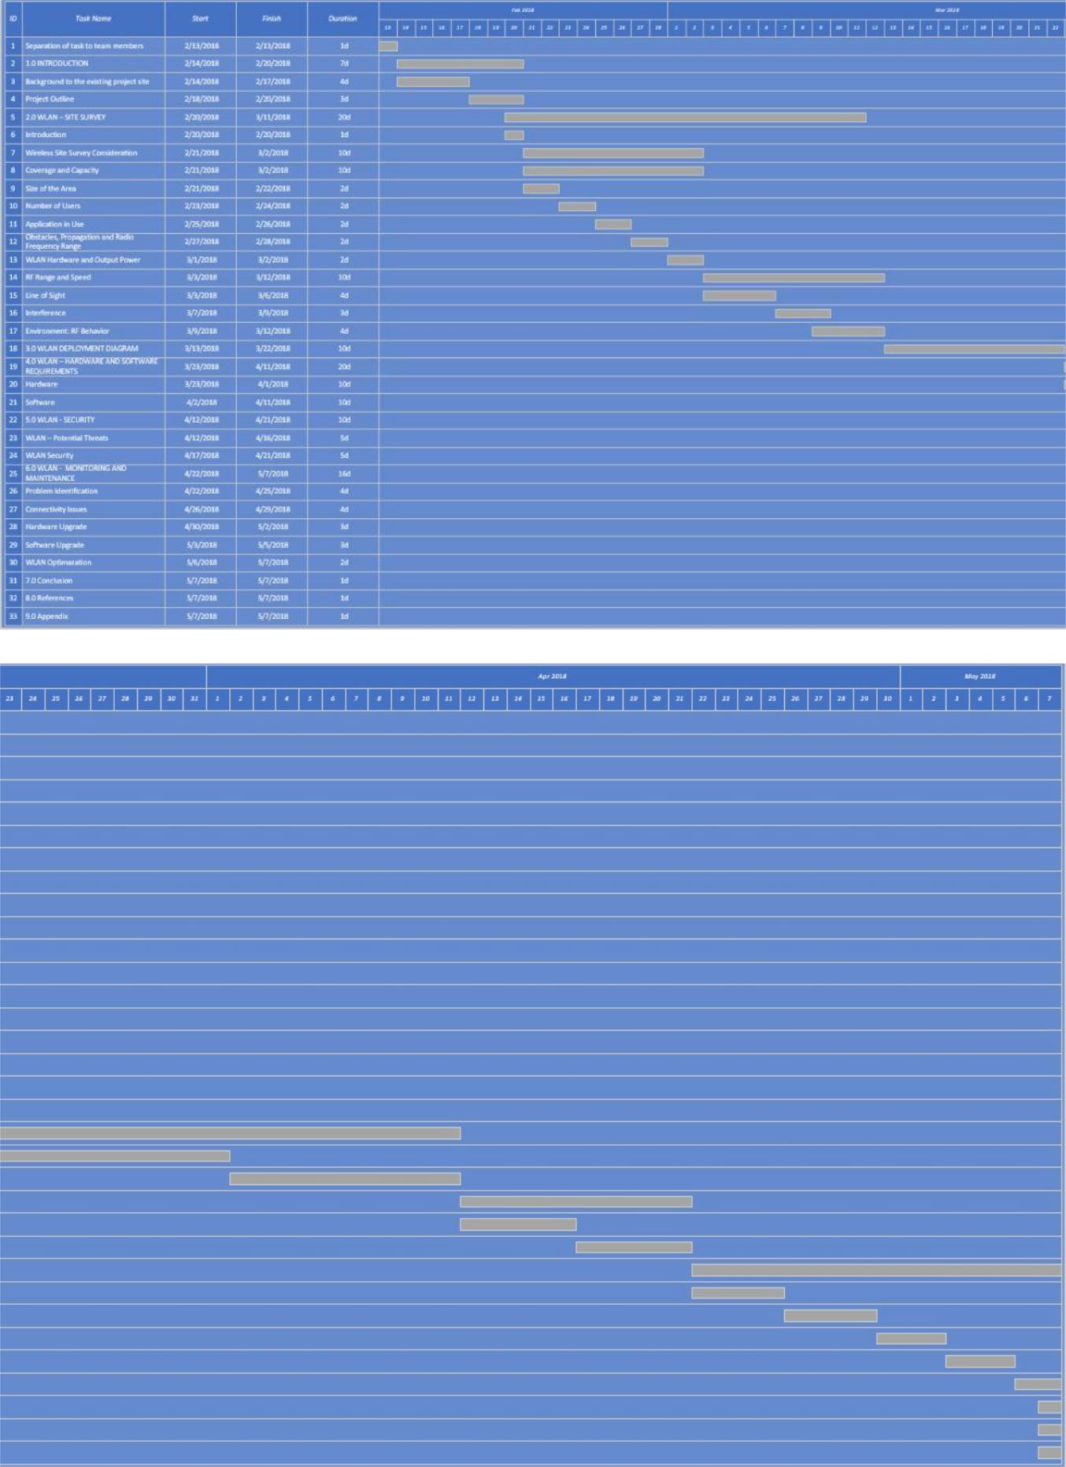

9

WORKLOAD MATRIX

 | Name |  |  | Ho Joon Hoe |  |  |  |  |  | Kho Zhi Yuen |  |  |  |  | Reuben Lau |  |  |  | Muhammad
 |  |  |  |  | (TP038711) |  |  |  |  | (TP038123) |  |  |  |  |  | (TP038516) |  |  |  |  | Hasan
 |  |  |  |  |  |  |  |  |  |  |  |  |  |  |  |  |  |  |  | (TP033594)
Introduction |  |  | 25% |  |  |  |  |  | 25% |  |  |  |  | 25% |  |  |  | 25%
WLAN – Site |  |  | 2% |  |  |  |  |  | 94% |  |  |  |  | 2% |  |  |  | 2%
Survey
WLAN – |  |  | 25% |  |  |  |  |  | 25% |  |  |  |  | 25% |  |  |  | 25%
Deployment
Diagram
WLAN – Hardware |  |  | 2% |  |  |  |  |  | 2% |  |  |  |  | 94% |  |  |  | 2%
and Software
Requirements
WLAN - Security |  |  | 94% |  |  |  |  |  | 2% |  |  |  |  | 2% |  |  |  | 2%
WLAN - |  |  | 2% |  |  |  |  |  | 2% |  |  |  |  | 2% |  |  |  | 94%
Monitoring and
Maintenance
Conclusion |  |  | 25% |  |  |  |  |  | 25% |  |  |  |  | 25% |  |  |  | 25%
 | Group |  |  |  | 100% Present |  |  |  |  | 100% Present |  |  |  | 100% Present |  |  |  | 100% Present
 | Meeting/Discussion
 | / Activity
 | Attendance
Signature


10

1. INTRODUCTION

1.1 Background to the Existing Project Site

Rural areas and smaller cities encounter limited telecommunications infrastructure, especially those which are geographically remote and has isolated telecommunications infrastructure. The broadband internet penetration and use in rural and remote area of developing countries has a distinguishable difference compared to the country’s city area.

Through assessments, it can be concluded that existing telecommunication network infrastructure in rural and remote communities reveals a low level of broadband penetration with many black spots where telecommunication infrastructures do not exist. One of the main reason is that a combination of poor telecommunications infrastructure coverage, low population density, inadequate regulation, and a focus by telecommunications companies on high-cost technologies designed for urban markets makes Internet connectivity in many parts of the rural and remote area a complex and costly proposition.

This comes off as a huge problem as due to inadequate information and communication infrastructure and facilities in rural and remote area, the digital divide between rural and remote communities and urban communities is widening. (Anon., 2018)

1.2 Project Outline

The team receives a project where the proposed network is designed to provide rural areas and smaller cities like the Bario Community Telecentre and a Bario Clinic a convenient, cheap and simple wireless solution. Bario Community Telecentre and Bario Clinic is located in a small and remote village Bario near KL, Malaysia that is currently lacking telecommunication infrastructure. Hence, the project team has been appointed to deploy a wireless local area network (LAN) for Bario Clinic connecting the existing wired LAN at Bario Community Telecentre.

1.2.1 Aim

The aim of such arrangements made is to ensure Bario Clinic’s doctors and nurses may gain access to Internet to perform crucial and relevant data and document’s management and basic web-browsing by leveraging on the current wired LAN at Bario Community Telecentre.

11
2.0 WLAN – Site Survey

Kho Zhi Yuen (TP038123)

2.1 Introduction

In a recap of the information explained above, there a few reasons as to why telecommunication infrastructure and facilities in rural and remote areas are not well-defined, given an example would be a complex and costly proposition.

Given the scenario, the project proposal where it is required to leverage off the currently existing wired LAN telecommunication infrastructure creates opportunities to allow a lowered project and implementation cost.

2.1.1 Network Scope

The proposed network is designed to provide a simple, convenient and secure way to provide Internet access to Bario Clinic while leveraging on the existing wired LAN telecommunication. There is an importance to note that the network is designed for administrative purposes and only for customer’s usage when it is urgently required.

2.1.2 Objectives of Proposed Network

The proposed network is designed to meet several specific operational objectives, which are listed below:

- High availability and reliability of network

  - The network should be available 24/7 and be highly reliable at all time to ensure service uptime is 100% and keep with user expectation and zero to none packet loss or unexpected errors.

- High security and protected network

  - The given use case displays a high need of customer’s privacy protection which contains personal information, medical and billing content, therefore the system must be secured and protected at all times. The implementation should provide the most basic security which is to be not easily hacked or attacked by denial of service attack.

- High network scalability

  - Given the fact that it is located in an underdeveloped location, the site’s landscape may be altered, changed or expanded based on the development of the rural site. Therefore, it is important to have good scalability of the network

12

system so that it is modify the implemented network infrastructure any given time.

2.1.3 Requirement Gathering

In order to fully understood the minimum requirement of the desirable network system from the use case, relevant interviews were conducted with the doctor, nurses and frequent customers of Bario Clinic.

Questions below are used to collect the requirements of the system:

- If the wireless solution is deployed in the clinic, will it improves your working experience in the company? If yes, what are your notable expectation of the network system?

- What problem do you faced with the current system?

- Any particular new features or measurements would you like to see in the new wireless solution?

- What are the possible problems that you would like to highlight to the specialists if the wireless solution is implemented?

- What are the estimated number of users to be?

- How many devices will actively be on the network at the same time?

- What are they being used for or what are your users trying to accomplish?

2.2 Wireless Site Survey Considerations

Through reviewing multiple relevant case studies, performing a preliminary investigating through interview, several professional assumptions and an on-site visit, the project team is able to generate a wireless site survey considerations’ report to lay out the prominent deliberations that should be highly noted.

Site Survey

Given that there are 4 types of site survey methods, the project team has decided to choose passive site survey and spectrum site survey.

Passive Site Survey

This method of site survey directly involves the project team to visit the site, where the team will run specialized software that measures the wireless signal from the access point to the wireless system. Since the act is passive, there is no connectivity but just a measurement of signal strength. At the end of the site survey session, a report will be generated where it shows

13

the heat maps, coverage of the environment and potentially dead spots or areas where they may be insufficient signal. This is selected as the team declares that it may be costly to perform a validation site survey when the implementation may not be fully confirmed workable.

Spectrum Site Survey

Spectrum site survey is used to detect sources of radio frequency (RF) interference within a given space. The project team will execute this particular site survey in conjunction with passive site survey. (McNamee, 2017)

2.2.1 Coverage and Capacity

Wi-Fi deployments requires a huge amount of planning where there several factors to consider. Coverage can be defined as the areas where end users’ devices are able to connect to the wireless network and it should answer these two questions:

- Where do the client needs RF coverage? Indoors? Outdoors? Both?

- How much throughput should it be as a benchmark?

Unlike purchasing paint, where it specify the approximate coverage area in square feet, however there is no simple rule that determines how much space a access point with cover with the RF energy it is transmitting. Hence, one of the first pieces of information to be collected is the size of the building or buildings in square feet, where is often represented as floor plans which will be displayed below.

2.2.1.1 Size of the Area

14

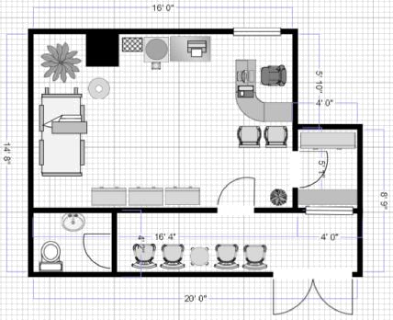

Figure 1: Bario Clinic

Bario Clinic is situated on top of a hill that is 100 metres away from the telecentre. This clinic is a single storey building that has a size of 300 square feet that has 4 rooms covering a patient waiting area, washroom, dispensary and the doctor’s office.

2.2.1.2 Number of Users

Number of users in an area greatly affects the RF coverage, this is because the more users connecting to an access point the less performance to be expected, this result is generated due to share bandwidth/medium. An alternative reason may also be too many users are using powerful application, therefore creating the issue of access point overload and resulting in slow performance. In this case study, the project team is able to identify the number of users through preliminary studies to further ensure the wireless solution will be provided to all potential users. (blackhazelnut, 2018)

2.2.1.2.1 Bario Clinic
User Group | Minimum | Maximum

Doctor | 1 | 1
Nurses | 1 | 2
Patients | 0 | 8
Total | 2 | 11

In the case of Bario Clinic, the frequent user would be the doctor, where excellent constant connectivity to the Internet is required. Next in priority would be the nurses, which will only require wireless connection if situations requested, based on case study review, requires only normal to good signal strength. Last in priority would be the patients, where the signal strength can not be taken into considerations. The maximum traffic that is currently detected is 11 users, which the project team has to take into considerations during the deployment of wireless communication.

2.2.1.3 Applications In Use

The applications in use are taken into considerations as the level of intensity the applications in use can affect the bandwidth. If there is a utilization of high bandwidth intensive applications such as CAD/CAM application, it may result in poor throughput. In alternative scenario, the wireless LAN hardware in use may also stands an impact.

2.2.1.3.1 Bario Clinic

In the case of Bario Clinic, there are a few applications that would be used, for example prescription software, electronic health records software, appointment scheduling software and medical billing software and basic web browsing software (such as Google Chrome) that was got to known through interviewing with the doctor.

With relevance to the paragraph above, the project team has identified a few applications that may require less-normal wireless connection which is 1) appointment scheduling software, where the doctor may upload available slots to allow customers to book an appointment with the doctor; 2) medical billing software, where the doctor is able to directly charge the customers the respective billings through online banking etc.

2.2.1.4 Obstacles, Propagation and Radio Frequency Range

There are multiple obstacles in an area that should be taken into considerations, for example walls, doors, windows, and furnishings, as well as the physical properties of these obstacles, which are thickness of the walls and doors, density of the windows and type of furnishings may also affect coverage.

The project team has decided to utilize the software AeroHive Network Planning Tool to draw the onsite materials which will be considered as the obstacles. The project team decides to display the decibel (dB) of each material which can measure signal strength.
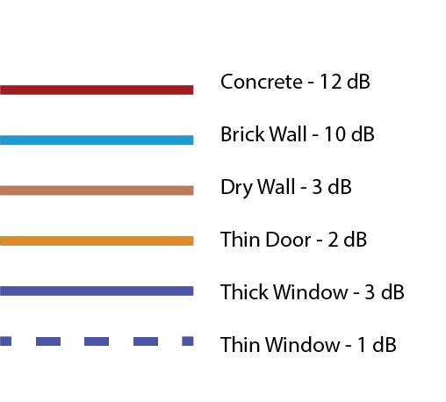

Figure 4: Materials

It is to be reminded that a 3 dB drop is equivalent to a 50% reduction in power.

2.2.1.4.1.1 Bario Clinic
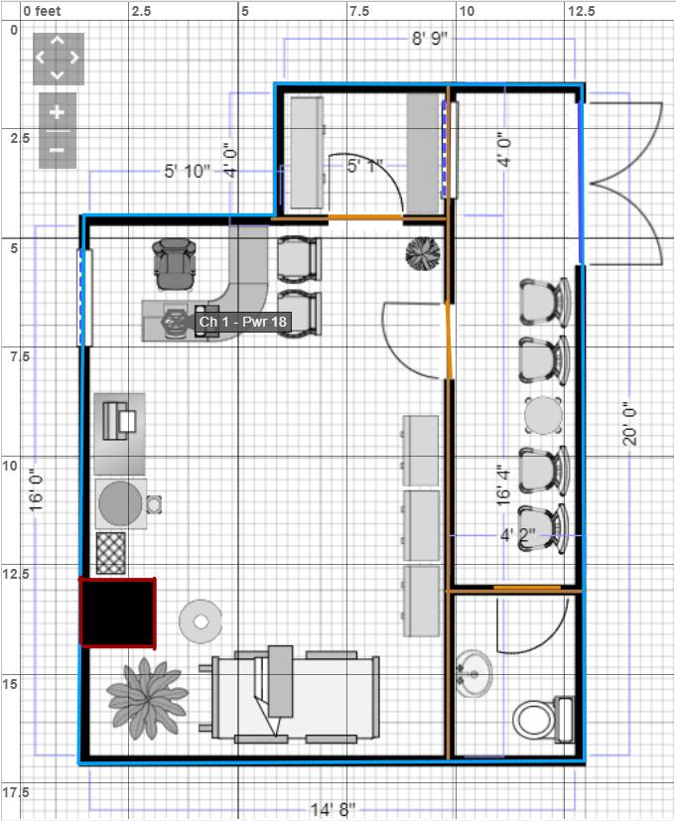

Figure 5: Materials (Clinic)

The Bario Clinic is built with brick walls separating the partitions with dry walls. There is one thin window beside the doctor’s table as well as in the dispensary for the nurse to pass the medicine to the patients. The clinic’s door is made out of thick glass. Mounted on the partitions are thin doors, separating the doctor’s office, washroom and dispensary. There is one pillar made out of brick for the clinic’s future development for 2nd floor. There is also plants that contains water. There are some electronic items in the doctor’s office such as twisted cable phone, water cooler and printer as well as shelves made out of steel, all which will cause diffusion.

20

2.2.1.4.2 Received Signal Strength Indication (RSSI)

-35 dBm - 70 dBm

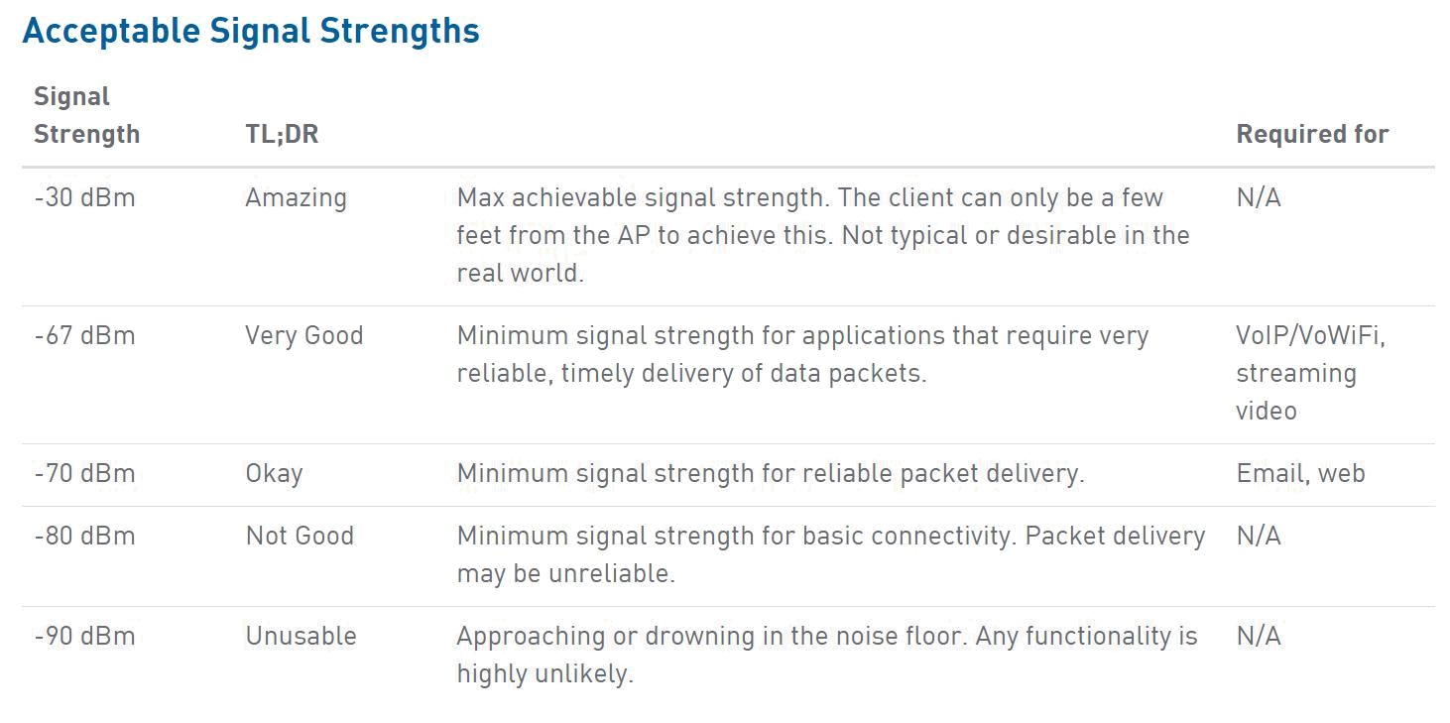

Figure 7: Acceptable Signal Strength

RSSI is a measurement of how well the projection of the signal from an access point or router. It is considered as a value useful for determining if there is adequate signal to receive a good wireless connection. According to Metageek, -30 dBm is the max achievable signal which is the most optimum signal strength whereas -90 dDm is the worst signal strength as there is too much noise posing as disruption. (MetaGeek, 2018)

In this case, by determining the materials, it is possible to stimulate the RSSI value in the building, this is to pave the possibility to correct determine which position to place each access point so that user in the building can fully utilize the speed of the network system.

According to research, the radio frequency used, which is either 2.4 GHz or 5 GHz will determine how well a signal will propagate and handle an obstacle. Therefore, the project team has decided to display the RSSI value based on two radio frequency, 2.4 GHz and 5 GHz to display alternated possibilities.

2.2.1.4.2.1 Bario Clinic (2.4 GHz)
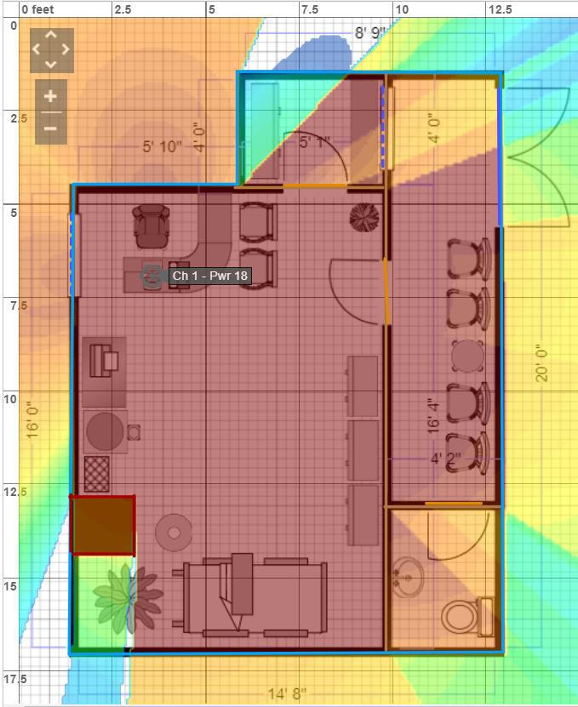

Figure 8: Heat Map (Clinic – 2.4 GHz)

With references to the figure above, it displays with the placement of access point above the doctor’s table, the signal may propagate in such manners. It is obvious that with the placement of a concrete wall with 12 dB resistance, the signal immediately gets weaker. This is can shown that the longer waves used by the 2.4 GHz band are better suited to longer ranges and transmission through walls and sold objects. (Klein, 2017)

23
2.2.1.4.2.2 Bario Clinic (5 GHz)
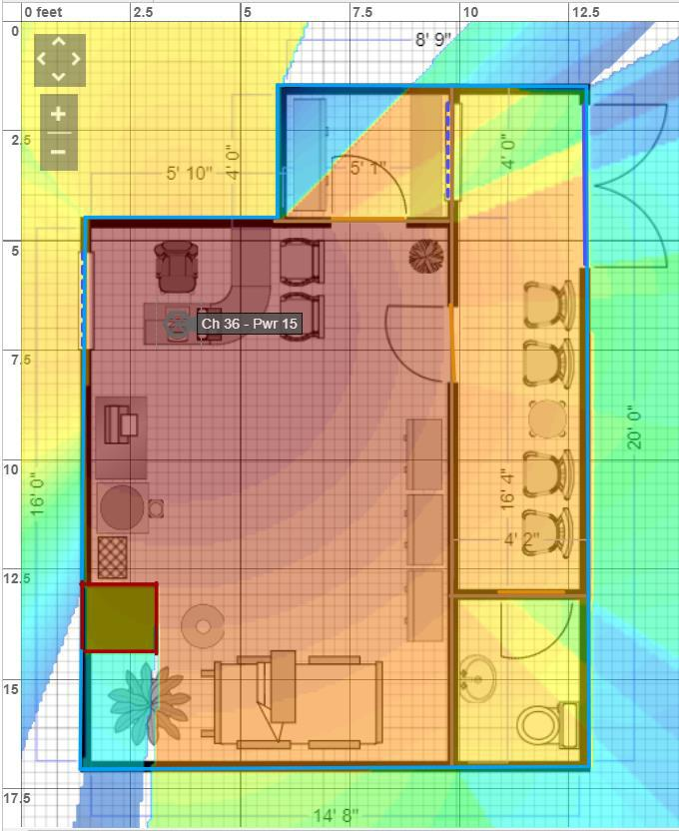

Figure 9: Heat Map ( Clinic 5 GHz)

With references to the figure above, it displays with the placement of access point above the doctor’s table, the signal may propagate in such manners. It is obvious that with the placement of a concrete wall with 12 dB resistance, the signal gets even weaker than with 2.4 GHz. This is can shown that with 5GHz band is much less congested, it means more stable connection. However, on the other hand, the shorter waves used by the 5 GHz makes it less able to penetrate walls and solid objects. It is obvious that it also got a short effective range than the 2.4 GHz band.

Figure 11: Heat Map (Telecentre - 5 GHz)

With references to the figure above, it displays with the placement of one access point and another router to maximize wireless connectivity that is randomly placed in the center of the telecentre, the signal may propagate in such manners. It is obvious that with such placement and the usage of 5 GHz band, the signal appears weaker than the usage of 2.4 GHz band, however with the reading of -70 dBm, it is still considered as a good signal strength for low-throughput tasks like sending emails or browsing the web which is relevant to the use case. (MetaGeek, 2018)

2.2.1.5 WLAN Hardware and Output Power

2.2.1.5.1 Output Power

With relevance to the router chosen, which is ASUS RT-AC3200, a tri-band gigabit router. Besides the router support of 2.4 GHz and 5 GHz, as a multi-band antennas’ router, all six antenna also supports 2.4 GHz and 5 GHz. With this selection for the use case, it creates a leveraged advantage for users’ devices that does not support 5 GHz to connect to the wireless solution.

2.2.1.5.2 Gain of Antenna

According to the RT-AC3200 manual page 124, it is noted in a table that the max gain for each antenna is 3.47 dBi. (eusriso, 2015)A transmitting antenna with a gain of 3 dB means that the power received far from the antenna will be 3 dB higher (twice as much) than what would be received from a lossless isotropic antenna with the same input power.

2.2.1.5.3 Antenna Orientation/Polarization

The antenna orientation for the selected router is omni-directional which radiation pattern is often described as doughnut-shaped, it orients vertically they radiated equally in all horizontal directions. However, according to this discussion, the recommended position for the antennas should be straight up and down (90 degrees) or at a 45-degree angle. (GrinningShark, 2016)

2.2.1.5.3.1 Antenna Type

Unlike isotropic antennas, the selected router uses dipole antenna which are real antennas, which represents the dipole radiation pattern is 360 degrees. As the beam is slightly concentrated, dipole antennas have a gain over isotropic antennas of 2.14 dB in the horizontal plane.

2.2.2 RF Range and Speed

According to research, how far and fast an RF signal can travel depends on a variety of factors, including 1) line of slight; 2) interference; 3) environment: RF behaviour.

2.2.2.1 Line of Sight

There are two types of line of sight, which is visual and RF. Based on the hardware and the solution that the project team has selected, we can confirm that visual line of sight is not the main concern, as the devices support RF line of sight, which the radio transmission would not be affected if the total area of radio frequency transmission (the Fresnel zone) is not blocked by more than 40 percent.

The Bario Clinic is situated on top of a hill, there is minimal obstacles such as trees, uneven terrains and curvature of the Earth which will interfere with the connection of the devices, therefore we can confirm that the choice of project team which will be RF, is because it favours the project requirements.

2.2.2.2 Interference

Interference from a radio frequency point of view occurs when a receiver hears two different signals on the same or similar frequencies. The conduction or radiation of radio frequency

energy that causes an electronic or electrical device to product noise that typically interferes with the function of an adjacent device. Hence, any device that uses the unlicensed 2.5 GHz band, may interfere with the wireless router, creating poor performance. The project team has identified a few elements such as medical devices located in Bario Clinic will creates interference as well, may have a severe impact on the quality of signal received by the wireless device.
2.2.2.2.1 Co-Channel and Adjacent Channel Interference
Co-channel or adjacent channel interference occurs when two devices in the same physical area are tuned to a close or same radio frequency channel. With relevance to the project, there is no such interference under this category as both of the routers that is placed in the telecentre has a different channel which was adjusted during the set-up. (Techopedia, 2018)

2.2.2.3 Environment: RF Behaviour

When designing a wireless network, it is also important to understand the propagations that may come with the materials within the deployment area. This is because as an RF signal travels through the air and other different mediums, it can move and behave in different manners. The project team has identified a few possible propagations based on the use case.

2.2.2.3.1 Reflection

Just like light, a wireless signal which composes of radio waves, may bounce off of certain surfaces. According to research, it can be specifically a smooth, non absorptive surface such as a table top and changes direction. It is also noted when the signal is getting reflected, it will lose signal strength. With relevance to the project’s site, metal is highly presentable in the Bario Clinic (medical appliances and metal shelves), which is for one, a highly reflective material. This is a common occurrence in clinics since most of the medical appliances are presented with a metal coating, which will generate a large amount of reflections, therefore weakening the signals and causing interference at the receiver. With this in considerations, the project team has decided to deploy the access points near the doctor’s desk which also has a limited number of medical appliances.

2.2.2.3.2 Refraction

When an RF signal passes between mediums of different densities, it may change speeds and also bends, this will creates loss of signal. This plays into considerations when the project team is placing the access points as it is important to track possible refraction when designing the

28

wireless network as if a signal changes direction in travelling from sender to receiver, this may cause lower data rates. With inspection to the project’s site, there are multiple windows (please do refer to the graphics in 2.2.1.4.1 On-site Materials) and glass doors. For example, the Bario Clinic, there is one thin window beside the doctor’s table as well as in the dispensary for the nurse to pass the medicine to the patients. In addition, the clinic’s main door is made out of thick glass.

2.2.2.3.3 Diffraction

This happens when waves encounter an obstacle and travels around it, where the wave’s direction and intensity both changes. According to the diagrams in the on-site materials and heat maps sections, a column situated in the Bario Clinic within the doctor’s office is subjected to this problem, resulting in some level of loss. This is acceptable as there will be no users situated behind the column, therefore not resulting in any problems that devices are not able to connect.

2.2.2.3.4 Scattering

Scattering can be most easily described as multiple reflections. This happens with a RF signal strikes an uneven surface, wave fronts of the signal will reflect off the uneven surface in several directions. In consideration to the project’s site, the site is not subjected to this problem as there are no major uneven surfaces such as stairs presented.

2.2.2.3.5 Absorption
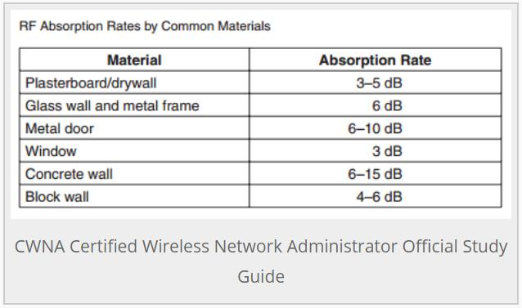

Figure 12: CWNA

When material absorbs an RF signal, no signal penetrates through the material. Water is an example of a medium that may absorb a signal to a large extent, where is largely presented in the human body. When in considerations of a densely populated area, the clinic will only have a maximum number of 11 people, which will not be affected. However, there are plants that contains water that may absorb the RP signal. (Blogspot, 2018)

29

3.0 WLAN – Deployment Diagram

The deployment diagram above displays the detailed WLAN deployment in Bario Clinic This diagram also explains in detailed the wireless solution that the project team has decided to deploy for the use case.

<Explanation of the diagram should be given in detail here>

